**Focus Keyword: Authentic Beauty Concept**

**Meta Title: Authentic Beauty Concept | Educatecast**

**Meta Description: Authentic Beauty Concept is a comprehensive premium brand designed to pave the path for authentic beauty.**

**Feature Image:**

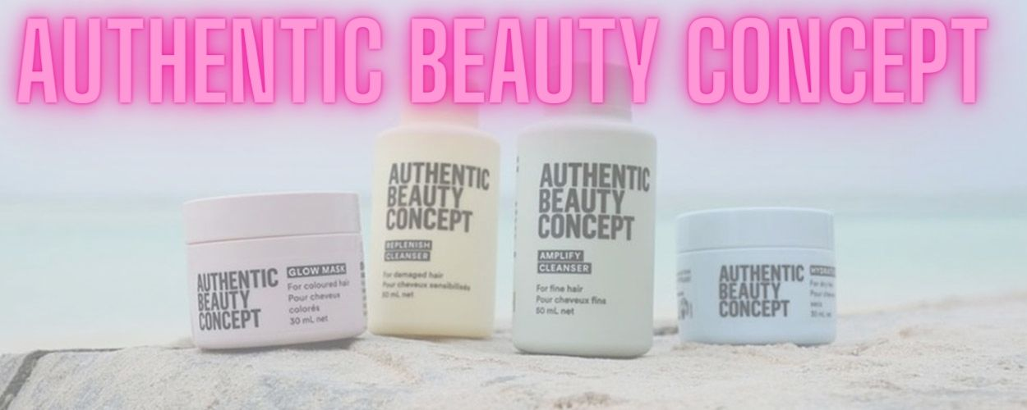

**Authentic Beauty Concept**

Authentic Beauty Concept is a comprehensive premium brand that was co-created with a one-of-a-kind hairdressing collective to pave the way for a new road to authentic beauty

Authentic beauty is something to be loved and valued since it is something that every woman possesses but is absolutely unique to her that no one can ever take away. It's a unique beauty that's great, honest, sincere, and so, so lovely.

**Authentic beauty Concept Hydrate Mask?**

A luxurious natural hair mask for keeping the brilliance of hair colour.

It contains date, rice, and cinnamon extracts, which moisturize, detangle, and leave your hair smooth and lustrous. More Reasons to Like It is that it is completely vegan and cruelty-free.

**How do you apply a hydrating hair mask?**

Step 1: Shampoo and rinse your hair.

Step 2: Put on your hair mask.

Step 3: Wait three to five minutes after step three.

Step 4 is to rinse.

Step 5: Towel dry and style your revitalized hair as usual.

**Precautions FOR USE:**

• Apply to clean, wet hair.

• Leave in hair for 5-10 minutes, then thoroughly rinse off.

• Best used after washing hair with Glow Cleanser and Glow Conditioner.

**Authentic Beauty Concept Glow Mask**

Authentic Beauty Concept Glow Mask 200ml is a profoundly nourishing vegan hair mask that improves softness and shine while preserving hair colour. The plant-based oils are responsibly obtained and give moisture to your hair, enhancing the conditioner and preventing flyaway.

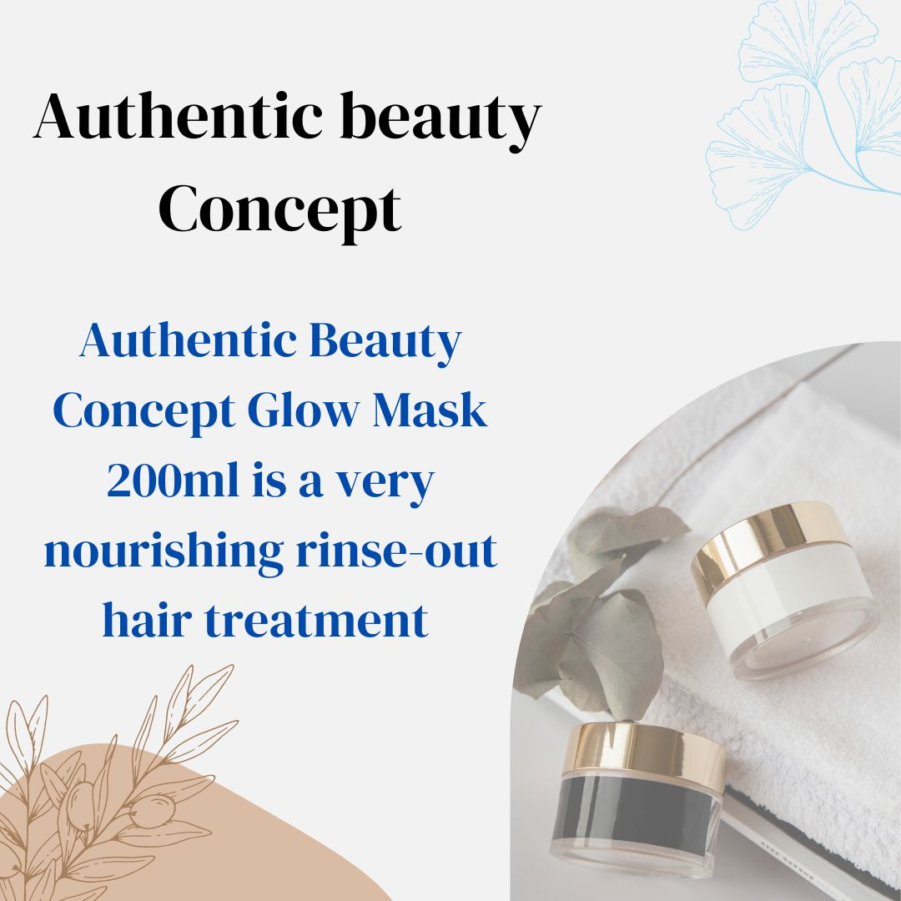

This color-preserving rinse-out treatment is an excellent weekend hair treatment. Although this mask is good for all hair types, it works best on color-treated hair.

The delicate yet delectable perfume of cinnamon and dates makes applying this hair mask a delightful experience.

**Authentic Beauty Concept Glow Mask Characteristics**

* The Glow Cleanser, like other Authentic Beauty Concept products, is colour safe, PETA approved, cruelty free, and vegan.
* This product is also devoid of parabens and phthalates.
* As with other

**Authentic Beauty Concept Products**

Every product they produce is not only vegan, but also free of Microplastics, mineral oil, parabens, silicone, and artificial colors.

**Authentic beauty Concept Products smells like?**

The vegan cosmetics business is well-known for its cutting-edge products. Authentic Beauty Concept has released a hair scent. The scent of the Eau de Toilette is fresh linen, white flowers, and powdered violet. It is safe to use on both skin and hair.

**Harmful Ingredients That Are Absent from Authentic beauty Concept Products:**

Microplastics, mineral oil, parabens, SLS/SLES sulphates*, silicones, Pthalates, Formaldehydes and Formaldehyde-releasing chemicals, Retinyl Palminate, Oxybenzone, Coal Tar, Hydroquinone, Triclosan, and Triclocarban are all absent from all formulae.

When discussing cleansers, the term "free from SLS/SLES sulphates" is used because these compounds are only present in cleansers and are not found in other types of goods.

**Synthetic scents in the Authentic beauty Concept Products?**

Yes, synthetic perfumes are used in Authentic Beauty Concept products. However, there is a frequent fallacy that natural is always preferable than manufactured. This is not always the case. Some natural scent compounds may not be sustainable owing to natural resource depletion.

**Characteristics of the Authentic Beauty Concept** **products**

* Sulfates are not present in Authentic Beauty Concept products.
* Gluten-free products are available from Authentic Beauty Concept.
* Parabens are not present in Authentic Beauty Concept products.
* Plant-based oils for moisture retention
* Cinnamon & date extract: Helps to improve and brighten your colour
* Lactic acid: Aids in the removal of dead skin cells and the improvement of scalp health.
* Moisturizes and detangles
* Leaves hair feeling silky and soft
* Sulfate, parabens, and silicone free

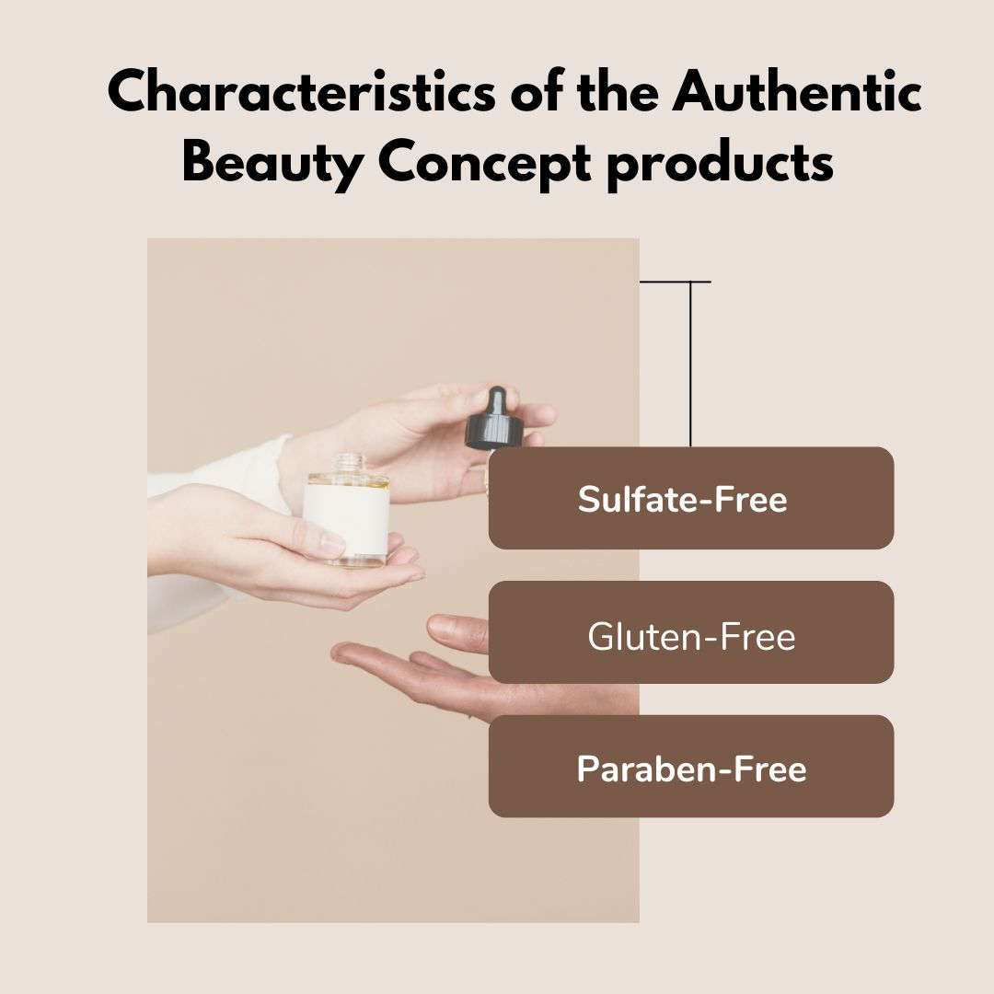

**Countries Supplying Authentic Beauty Concept products:**

Germany, Austria, Switzerland, Spain, Portugal, the Netherlands, Belgium, France, the United Kingdom, Ireland, Finland, Sweden, Greece, Poland, the Czech Republic, Hungary, Croatia, Slovakia, Russia, Turkey, South Africa, Japan, Colombia, the United States, Canada, Mexico, Israel, the Gulf Cooperation Council (United Arab Emirates and the Kingdom of Saudi Arabia), Brazil, and Argentina.

**Authentic Beauty Concept FAQs**

1. **Are the products of Authentic Beauty Concept natural?**

Authentic Beauty Concept is not an all-natural company, but it aims to design products with as many natural or organically derived components as possible, while keeping performance and efficacy in mind. Each product is meticulously designed with a combination of natural, organically derived, and synthetic substances as needed to ensure peak performance.

1. **Can Authentic Beauty Concept products be used on curly hair?**

Yes! It is best to begin with the Hydrate Range. Authentic Beauty Concept is constantly growing its inventory to include items that cater to a variety of textures.

1. Are the products of Authentic Beauty Concept colour safe?

Though the Glow range's major purpose is to preserve color-treated hair, all other hair care products are equally color-safe.

1. **Are the products of Authentic Beauty Concept vegan?**

The Vegan Society has certified that Authentic Beauty Concept products are vegan.

1. **Is it safe to use Authentic Beauty Concept Color?**

Though the Glow range's major purpose is to preserve color-treated hair, all other hair care products are equally color-safe.